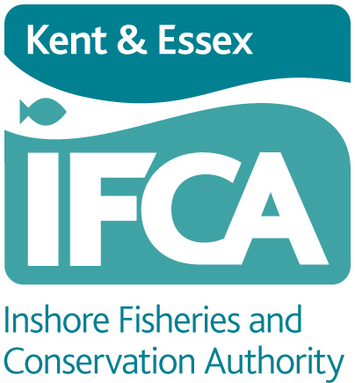

KENT AND ESSEX INSHORE FISHERIES & CONSERVATION AUTHORITY
Paragon House, Albert Street, Ramsgate, Kent, CT11 9HD

2023 PERMIT APPLICATION UNDER THE
COCKLE FISHERY FLEXIBLE PERMIT BYELAW

I hereby make application to the Kent and Essex Inshore Fisheries & Conservation Authority under the Cockle Fishery Flexible Permit Byelaw for a permit to fish for cockles within the Authority’s District (a summary of the byelaw is set out overleaf, the full byelaw is available to view at our website www.kentandessex-ifca.gov.uk).

I wish to apply for a Category One permit OR a Category Two permit

APPLICANT DETAILS

Full name: (please print) ...............................................................................................
(Individual’s name not name of Company)

Address: (please print): .................................................................................................

....................................................................................................................................

....................................................................................................................................

Telephone: (land line) ................................ Telephone: (mobile) ...................................

E-mail address: ...........................................................................................................

Date of Birth: ..............................................................................................................

VESSEL DETAILS

Vessel Name: ..................................................................... Vessel PLN: .....................

Vessel Length: (metres) ............................. Vessel breadth: (metres) ...........................

Engine power: (kilowatts) .............................................................................................

If engine is de-rated please state power before de-rating ....................................................

Method of Taking Cockles: Loose loading bags

I have included:

Payment (£1272 Category One or £636 Category Two)

Copy of MMO Licence

Copy of Vessel Registration

Copy of photographic ID

Signed: ........................................................... Date: .................................................

COCKLE FISHERY FLEXIBLE PERMIT BYELAW (summary only, for full byelaw see website: www.kentandessex-ifca.gov.uk)

No person shall harvest or disturb cockles other than in accordance with a category one permit or a category two permit.

No person shall harvest cockles using a relevant fishing vessel which exceeds 14 metres in overall length or exceeds 5 metres in overall width.

No more than one permit will be issued per relevant fishing vessel.

Permits are not transferable between the permit holder and another person or between the named vessel and another vessel

A person applying for a category one permit or a category two permit may nominate up to two persons as their representatives (“nominated representatives”), provided that a person nominated is not:

(a) A category one permit holder;
(b) A category two permit holder; or
(c) Already nominated as a representative on a category one permit or a category two permit.

Permits issued by the Authority shall be valid from the date of issue until the 31 December of that year and are issued on the condition that the holder of the permit shall complete and return to the Authority as required a record of daily catch, actual fishing time and fishing area. Such information shall be submitted on a form provided by the Authority.

Applications for a permit under this byelaw are to be made in such form as the Authority shall determine.

DATA PROTECTION

Kent & Essex Inshore Fisheries collects this data in accordance with the Data Protection Act 1998. The information will be used to process your application and stored so KEIFCA can maintain a record of authorised Permits. The information will be stored for 3 years.

We will not pass your information on to a third party, unless you give us express permission to do so or the third party is carrying out work on our behalf. The third party will only be able to use the information to carry out their work.

Requesting access to your personal data

Under data protection legislation, you have the right to request access to information about you that we hold. To make a request for your personal information, contact the Data Protection Officer, Debbie O’Shea, Tel: 01843 585310 or Email: debbie.oshea@kentandessex-ifca.gov.uk

You also have the right to:
- object to processing of personal data that is likely to cause, or is causing, damage or distress
- prevent processing for the purpose of direct marketing
- object to decisions being taken by automated means
- in certain circumstances, have inaccurate personal data rectified, blocked, erased or destroyed; and
- claim compensation for damages caused by a breach of the Data Protection regulations

On occasions we are asked to supply information/data to other statutory bodies. If you are willing for your contact details to be shared, please tick the box below.

I give permission for my contact details to be shared

PAYMENT TERMS

Cheques: made payable to ‘Kent & Essex Inshore Fisheries and Conservation Authority’
Send to: Paragon House, Albert Street, Ramsgate, Kent, CT11 9HD

Payment Via BACS – Bank Account details:

Name of Account holder Kent & Essex Inshore Fisheries and Conservation Authority
Name of Bank Lloyds TSB
Address Branch – Ramsgate (309693)
Branch Sort Code 30-96-93
Account Number 01402853
Trans Code 84
BIC LOYDGB21239

Cheque payments Application will be processed within 7 working days from receipt of payment

BACS payments Application will be processed within five working days

Cash payments Application will be processed as soon as possible. Please make every effort to bring the correct amount of cash. Change may not necessarily be available.

