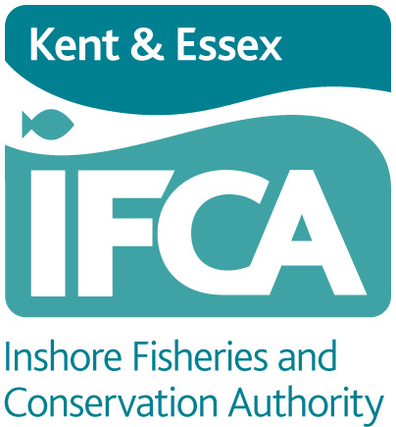
KENT AND ESSEX INSHORE FISHERIES AND CONSERVATION AUTHORIY
Paragon House, Albert Street, Ramsgate, Kent, CT11 9HD
Tel: 01843 585310 Website: www.kentandessex-ifca.gov.uk

WHELK FISHERY FLEXIBLE PERMIT BYELAW
WHELK POT PERMIT AND TAG APPLICATION FORM

I hereby make application to the Kent and Essex Inshore Fisheries and Conservation Authority for a Category Two Permit and tags to authorise the setting of whelk pots within the Authority’s district during the 12 months commencing 1 April 2023 under the terms and conditions of the Whelk Fishery Flexible Permit Byelaw.

FULL NAME OF APPLICANT:

ADDRESS OF APPLICANT:

TELEPHONE  LANDLINE: | MOBILE:
E-MAIL ADDRESS:

DATE OF BIRTH:
NAME OF VESSEL & PLN NUMBER:

DEFRA/MMO Fishing Licence No., including category:

Please include copies of the following documents with this application:

- Certificate of Registry
- MMO Fishing Licence
- Photographic ID, such as driving licence or passport

Signed: ................................................................................................. Skipper

................................................................................ Name (Please Print)

Signed: ....................................................................... Vessel Owner (if different)

................................................................................ Name (Please Print)

Date: ...............................................................................................................
COLLECTION OF TAGS: - PLEASE COMPLETE

I require ___________________ (maximum 10) tags and will collect them from the Ramsgate/ Brightlingsea Office*

*Delete as appropriate

CHARGES

The permit fee is £30
Tags are charged at 30p each

PAYMENT TERMS
CHEQUE PAYMENT | made payable to ‘Kent & Essex Inshore Fisheries and Conservation Authority’
Send to | Paragon House, Albert Street, Ramsgate, Kent, CT11 9HD
BACS PAYMENT
Bank account name | Kent & Essex Inshore Fisheries and Conservation Authority
Bank address | Branch – Ramsgate (309693)
Bank sort code | 30-96-93
Bank account number | 01402853
Bank trans code | 84
BIC | LOYDGB21239
CASH PAYMENT | Please make every effort to bring the correct amount of cash. Change may not necessarily be available.

DATA PROTECTION

The data supplied on this form is covered by the General Data Protection Regulations 2016. Kent & Essex IFCA has the right to process this data under Article 6(1)(c) of this Act as your data fulfils a legislative function. Your data is processed by Kent & Essex IFCA under a legal obligation conferred in sections 155 & 156 of the Marine and Coastal Access Act 2009 to process your permit, as is required by the Whelk Fishery Flexible Permit Byelaw.

We will only use your data provided on this form to process and monitor your permit. This consent to do so will remain in force until the permit ceases. You have the right to withdraw your consent for this at any time however, this will revoke the permit. The data is also held securely on Kent & Essex IFCA’s server.

In addition, we use your data to send you information on upcoming changes to legislation, formal and informal consultations on future byelaws and wider initiatives that may affect you. You have the right to withdraw your consent for this at any time.

We retain your data for three years following your application for a permit, after which it will be removed and destroyed. Electronic copies also have personal data removed three years after the permit has been issued.

If you would like to access any of the information we hold about you, or you have concerns regarding the way we have processed your information, please contact: Will Wright, Data Protection Officer, KEIFCA, Paragon House, Albert Street, Ramsgate, Kent, CT11 9HD. Telephone 01843 585310 or email will.wright@kentandessex-ifca.gov.uk

On occasions we are asked to supply information/data to other statutory bodies. If you are willing for your contact details to be shared, please tick the box below.

I give consent for my contact details to be shared

