Review of current management and development of future management related to the cockle fisheries within the Kent and Essex IFCA District
Listening Phase Questionnaire
Questionnaire information and background
Cockle stocks within the KEIFCA District are currently managed under two different legislative management regimes. The cockle stocks in the majority of the district are managed under a KEIFCA byelaw called the Cockle Fishery Flexible Permit Byelaw (CFFPB). However, the main production beds contained within a specific area of the Thames Estuary are managed by KEIFCA under a Statutory Instrument called the Thames Estuary Cockle Fishery Order 1994 (TECFO).
On the 28 September 2024 the TECFO, which started in 1994 for a period of 30 years, will end. Although this is three years away, the ending of the TECFO provides an opportunity to review how cockle stocks are managed, as well as the underpinning legislation, across the District including within the current TECFO area.
The purpose of this questionnaire is to collect information and views on the current management and running of the cockle fisheries with the district of Kent and Essex IFCA, both within the Thames Estuary Cockle Fishery Order (TECFO) area and the rest of the district that is covered by the KEIFCA cockle fishery flexible permit byelaw (CFFPB).
The questionnaire also helps gather views on how the cockle fisheries could be run in the future, with specific focus on the regulatory legislation that could be used to manage the fishery (Regulating Order or a Byelaw) and the possible mechanisms governing how fishers could access and exit the fishery. We would strongly encourage interested stakeholders to fill in as much of the questionnaire as possible as replies will help KEIFCA members understand your issues, gather data and numbers that we will use to evaluate potential management options and help us prioritise work and possible management options.
Throughout the questionnaire you will find BLUE boxes which provide background information for you to refer to prior to answering.
Undertaking a review of the current management and developing future management for the cockle fisheries within the KEIFCA District is complex, with many different stakeholders with many different views. Whilst there are a lot of questions within this questionnaire, we believe that it is critical to understand all points of view and collect as much information as possible during this listening phase.
To facilitate you working through this questionnaire we have broken it down into 3 sections. Section 1 is on your background. Section 2 is a non-technical questionnaire and section 3 is a technical (from a fisheries perspective) questionnaire. You can complete just one section or both sections. Section 3 is then broken down into the following five categories:
- How the fisheries currently work
- Regulatory options
- Access to the fisheries
- The economics of the cockle fisheries
- The proposed process for reviewing and developing management

How to respond

Please email your completed questionnaire to info@kentandessex-ifca.gov.uk. The closing date for receipt of questionnaires for this listening phase is 8th November 2021.

Any questionnaires received after 8th November 2021 will not be considered.

Who we are

Kent and Essex Inshore Fisheries and Conservation Authority (KEIFCA) was established on 1st April 2011 under provisions contained within the Marine and Coastal Access Act 2009 to manage the sustainable exploitation of sea fisheries resources within an area of over 3,412 km2, which extends from the east end of Rye Bay in Kent to the northern boundary of Essex on the River Stour, including the development and implementation of management measures and the enforcement of compliance with such in addition to national and international fisheries legislation.

Consultation timeline and decision-making process
The proposed process to review and develop future cockle management is split into a number of time defined steps that will build on each other, with the overall aim of confirming new legislation (in whatever form it might look like) to be in place for when the current TECFO legislation ends in September 2024.
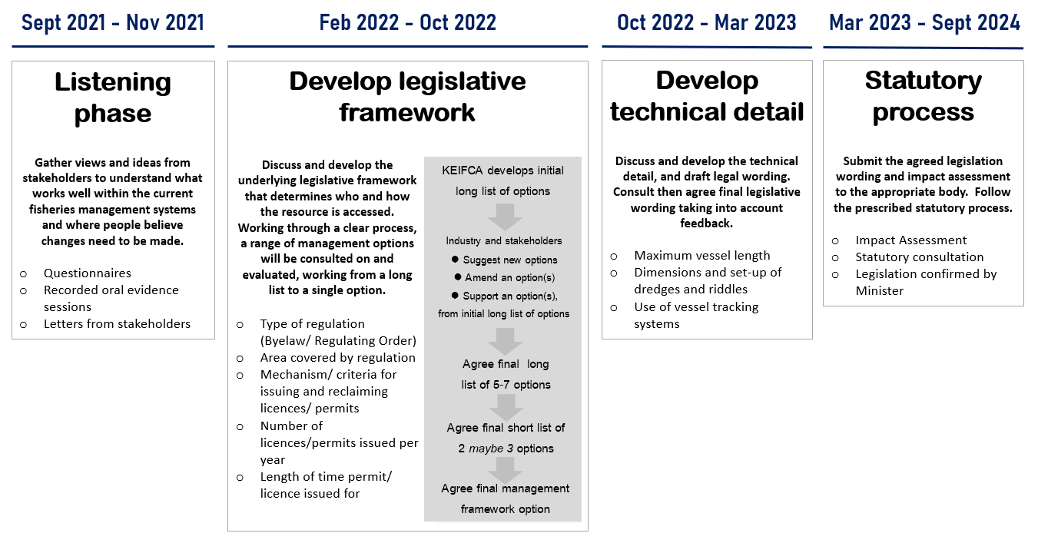

How to get more information
Contact:
- Website: www.kentandessex-ifca.gov.uk

- Email: info@kentandessex-ifca.gov.uk

- Telephone: 01843 585310

Privacy Policy
KEIFCA has a legal duty to manage the sustainable exploitation of sea fisheries resources within its district. These are set out in the Marine and Coastal Access Act 2009. The Authority cannot deliver this duty without processing personal data. For full details of our privacy policy go to our website https://www.kentandessex-ifca.gov.uk/privacy-policy.
How we use your personal information
We collect and use this information in order to:
- facilitate your participation in our consultation and engagement activities
- understand your views about a particular topic or KEIFCA activity
- analyse consultation and engagement activity
- communicate information to you about engagement and consultation opportunities, events and other initiatives, if you have requested to be kept informed

How long your personal data will be kept
We will hold any personal information provided by you as part of engagement or consultation activity for up to six years following the closure of a consultation.
Reasons we can collect and use your personal information
For engagement and consultation activity carried out in respect of this consultation we rely on UK GDPR Article 6(1)(e): ‘processing is necessary for the performance of a task carried out in the public interest' and Article 6(1)(c) ‘for compliance with a legal obligation to which the controller is subject’ as our lawful basis.
Information provided to the IFCA through all its consultations/listening phases will be provided in its entirety to Members of the IFCA. Redacted copies of this information (ie personal/identifying details are removed) will be made available on a public facing sharepoint which can be accessed by anyone who wishes to view it by applying to KEIFCA at info@kentandessex-ifca.gov.uk or by phone to 01843 585310. No personal information which can identify you, such as your name or email address, will be used in producing reports unless you specifically allow us to. We will follow our Data Protection policies to keep your information secure and confidential.

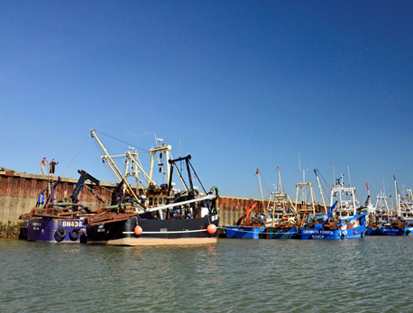 | 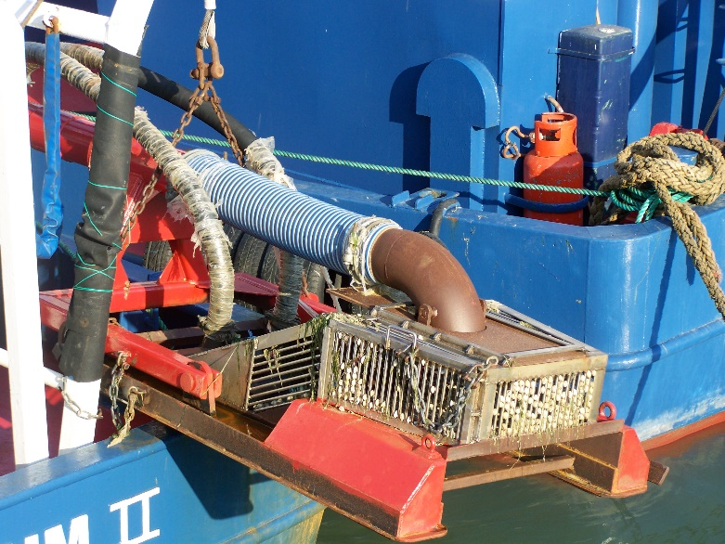

Section 1 – Background on Respondent
Collecting information about you and your background is important to us as it helps us better understand your point of view. The information provided below will help us make sure your information is included when we start to develop and evaluate different future management options. Items with an asterisk * are mandatory questions as they help us validate all of the responses that we get.
S1.1 | *Name | Click or tap here to enter text.
S1.2 | *Address | Click or tap here to enter text.
S1.3 | *Email | Click or tap here to enter text.
S1.4 | *Phone | Click or tap here to enter text.
S1.5 | *Age range | Choose an item.
S1.6 | *Area of interest | Choose an item.

S1.7 | *Are you responding on behalf of a company or organisation? If so, please specify which. | Yes ☐  No ☐
 | Company/Organisation: Click or tap here to enter text.
S1.8 | *Do you currently work, or have you previously worked, in the cockle industry? | Yes ☐  No ☐

S1.9 | If yes for (S1.8), for how long and in what role(s)?
Role/Job |  | Owner | Skipper | Crew | Processor
Length of time (years) |  | Click or tap here to enter text. | Click or tap here to enter text. | Click or tap here to enter text. | Click or tap here to enter text.

S1.10 | Would you apply for a permit/ licence if a new application process was available? | Yes ☐  No ☐
S1.11 | *Do you have access to licenced fishing boat as an owner and/or skipper? | Owner ☐ No ☐  Skipper ☐
S1.12 | *Boat name and PLN | Click or tap here to enter text.  Not applicable ☐
S1.13 | Can the licenced fishing boat you have specified be rigged up with a suction dredge and riddle? | Choose an item.

Section 2 – Non-technical Questionnaire
We are keen to hear from anyone who has an interest in the Thames and the KEIFCA cockle fishery as we are currently reviewing all the current cockle fishery management and regulations and looking to develop future cockle management. Whether the cockle fishery provides you with a direct or indirect income, is a valued habitat supporting a wider ecosystem, an important historic cultural activity that has taken place for generations or part of the local identity of your town, we want to hear from you.
Cockle fishing in KEIFCA District

The cockle fisheries within the Kent and Essex IFCA District are some of the oldest and most important cockle fisheries in Europe, and cockle harvesting has been a mainstay in the Thames Estuary for centuries providing a key industry for the local coastal fishing community. Due to the proximity to London, Thames cockles have long been associated with day trips to the seaside, be it from paddle steamers in the 19th Century to modern day family trips to ports like Leigh-on-Sea or Whitstable. The modern-day cockle fisheries provide income and jobs for a large number of fishermen, local processors and wider support companies, and cockles are sold into national and international markets usually as a canned product.

Historically, the cockle fishery was a year-round hand-raked fishery, focused on South Essex and North Kent beaches. Local fishermen would sail to the main harvesting grounds, allow their vessels to dry out on the beach and then hand-rake cockles into small net bags which were then transferred to baskets. The fishing vessels would then re-float on the flood tide, travel back to their home ports, and cook the cockles in shore-side sheds before selling them direct to the public. Over time, the industry became more mechanised and hydraulic suction dredges began to be used by the industry in the 1960s. The development of new harvesting systems saw the introduction of the solids handling pump in the early 1990s which have been further developed into the suction dredges used by the fleet today.

Biology and ecology of the cockle fisheries

The cockle (Cerastoderma edule) is a common shallow-burrowing bivalve that is usually found in the middle to low shore areas of beaches and mudflats. Cockles are generalist, opportunistic filter feeders; they have very short siphons and generally live within the top 5 cm of the surface of the beach so that they can reach the overlying water for feeding and respiration.

Spawning normally occurs in the summer, and individuals can produce between 200,000 - 700,000 eggs per animal. Cockle larvae are planktonic, and typically spend around 3-5 weeks floating in the sea before they start to settle. At many locations, settlement of small cockles, known as spat, may initially occur low on the shore, followed a few weeks later by movement to a secondary settlement higher on the shore. Most cockles live for between 2-4 years, but some individuals have been found to be over 10 years old. Cockles have many predators at different stages in their life history, including brown shrimp, shore crabs, starfish, snails, worms, fish (flounder, plaice) and a variety of birds particularly oystercatchers and knots.

Fishing with Marine Protected Areas

The cockle fishery takes place with a complex mosaic of Marine Protected Areas (MPAs) and the cockle stocks provide food for a wide range of bird and fish species, whist also providing other wider environmental benefits such as filtering seawater and CO2 capture. As the fishery occurs within the boundary of the Essex Estuaries European Marine Site, Habitat Regulation Assessments (HRAs) are completed on an annual basis in order to ensure the compatibility of the fishery with the designated features of the site. Bi-annual stock assessments are used assess the cockle stocks within the site and help inform a number of key technical, temporal and spatial management measures that manage the impact of the fishery within the site.

S2.1. How do the current cockle fisheries within the KEIFCA District impact you, your business or your interests and why do you think it is important?
Click or tap here to enter text.

S2.2. What do you think the priorities for the management of the KEIFCA District cockle fisheries should be between now and 2054?
Click or tap here to enter text.

S2.3. Are there any key objectives or important aims you think should be included in any future management criteria of cockles within the KEIFCA District?
Click or tap here to enter text.

S2.4. What do you think could harm the management of the cockle fisheries within the KEIFCA District between now and 2054?
Click or tap here to enter text.

S2.5. Is there any new technology that you think could be key to unlocking the long-term sustainable value of the cockle fisheries and protecting the marine ecosystem?
Click or tap here to enter text.

S2.6. Are there any particular aspects of the current cockle fisheries management measures that you think should change?
Click or tap here to enter text.

S2.7. Are there any particular aspects of the current cockle fisheries management measures you think are important to keep?
Click or tap here to enter text.

S2.8. Do you have any other comments you would like to make on the review of current, and development of future, cockle fishery management within the KEIFCA District?
Click or tap here to enter text.

Section 3 – Technical Questionnaire

- How the fisheries currently work
In this section we would like to get your views on the current underpinning processes KEIFCA uses to manage the cockle fisheries in the TECFO area and wider cockle fishery flexible permit byelaw (CFFPB) area. The processes KEIFCA have developed to manage the cockle fisheries have evolved over the last 25 years and now play an important part in annual assessments (HRA and MCZ assessments) that mean the fisheries can take place within Marine Protected Areas.
TECFO annual management process

The annual cockle fishery cycle starts in late March (usually over the Easter weekend) with the 5-7 day quadbike survey of the Maplin Sands cockle stocks. Working over a low tide window officers complete a quadrat survey where cockles from each quadrat are counted, aged and weighed to provide data on the condition of the stock. Areas within the TECFO area that can’t be reached by quadbike are surveyed by sea using a day grab deployed by either FPV Tamesis or FPV Nerissa and collect the same data. Overall, 1200 samples are taken over a 4 week period and this helps officers calculate a Total Allowable Catch (TAC) and develop annual management measures including temporal and spatial restrictions such as closed areas, open/close times and trips per week etc.

By the beginning of May, the surveys and the analysis have been completed, and a management meeting is held (usually at Leigh-on-sea) with the TECFO licence holders and their representatives. Officers outline the TAC for the year and run through the proposed management measures, there is then a discussion about the proposals, and where possible, officers will answer questions. Running in conjunction with this KEIFCA officers complete an annual HRA for the fishery and submit it to Natural England.

Using the results from the survey, the HRA requirements and the feedback from the industry, officers then finalise the management papers and recommendations that are put before the Authority at the May quarterly meeting. Stakeholders including members of the industry can attend the public quarterly meeting and (following standing orders) can comment on the proposals and suggest different alternatives. KEIFCA members then discuss the management paper and vote on the recommendations.

Once the management measures have been agreed, the fleet prepares for the upcoming fishery and KEIFCA officers start inspecting the gear that will be used in the fishery (including biosecurity inspections). The TECFO fishery usually starts in late June and, following the agreed schedule of fishing trips per week, each vessel can land 13.6m³ of cockles per trip.

Cockle vessels are inspected on a very regular weekly/biweekly basis by officers and fishing gear is inspected at the start of the season in-situ to make sure it is working within legal limits. Each vessel operating within the TECFO fishery is required have a Vessel Monitoring System (VMS) which reports the location of the vessel every 5 minutes. Data from this VMS system, when analysed at the end of the fishing season, can be used to calculate the physical impact of the cockle dredges on the seabed. This information is used to provide information regarding the impact and sustainability of the cockle fishery which occurs within a complex mosaic of MPA’s.

The second annual cockle survey takes place in mid-September and repeats the quadbike survey on the Maplin Sands but only samples every other survey point. Information from this survey feeds into the management process and is used to adapt management measures if required. A report on the cockle fishery is then presented to the Authority at the September quarterly meeting with any additional recommendations if required. The TEFCO fishery usually ends in October and an annual cockle report is completed prior to the January Authority meeting.

CFFPB fishery annual management process

As with the TECFO fishery, the annual management cycle starts with a spring survey where cockle stock data (numbers, density, age and weight) are collected in exactly the same way as within the TECFO area. As the cockle stocks outside the TECFO area are more discrete and less consistent, the stocks need to be above levels agreed in the management plan that accompanies the byelaw.

Management papers with recommendations are presented to the Authority at the May quarterly meeting. Due to the nature of the distribution and amount of stock available, only one area in the last 10 years has met the criteria for the cockles to be fished. This means the decisions and recommendations to manage this fishery are historically very limited and have been to allow either 1 trip or very occasionally 2 trips within a 1-2 week window in early October. As with the fishery within the TECFO, a HRA is completed and agreed before the fishery is opened.

If the fishery is opened, a significant enforcement operation swings into action, with biosecurity and gear checks being undertaken in-situ before the fishery starts. Unlike the TECFO fishery, VMS tracking is not universally available and so a significant sea-based enforcement presence is deployed to ensure that fishing takes place as per the agreed management measures.

S3A1. How would you rate the following aspects of the management of the current cockle fisheries?
- Annual cockle surveys and stock assessments
Fishery | Very good | Good | Okay | Neither good nor bad | Poor | Very poor
CFFPB | 1 ☐ | 2 ☐ | 3 ☐ | 4 ☐ | 5 ☐ | 6 ☐
TECFO | 1 ☐ | 2 ☐ | 3 ☐ | 4 ☐ | 5 ☐ | 6 ☐
Explain the rationale for your response here
Click or tap here to enter text.

- Reports
Fishery | Very good | Good | Okay | Neither good nor bad | Poor | Very poor
CFFPB | 1 ☐ | 2 ☐ | 3 ☐ | 4 ☐ | 5 ☐ | 6 ☐
TECFO | 1 ☐ | 2 ☐ | 3 ☐ | 4 ☐ | 5 ☐ | 6 ☐
Explain the rationale for your response here
Click or tap here to enter text.

- Annual meetings and management process
Fishery | Very good | Good | Okay | Neither good nor bad | Poor | Very poor
CFFPB | 1 ☐ | 2 ☐ | 3 ☐ | 4 ☐ | 5 ☐ | 6 ☐
TECFO | 1 ☐ | 2 ☐ | 3 ☐ | 4 ☐ | 5 ☐ | 6 ☐
Explain the rationale for your response here
Click or tap here to enter text.

- Setting Annual TAC (Total Allowable Catch)
Fishery | Very good | Good | Okay | Neither good nor bad | Poor | Very poor
CFFPB | 1 ☐ | 2 ☐ | 3 ☐ | 4 ☐ | 5 ☐ | 6 ☐
TECFO | 1 ☐ | 2 ☐ | 3 ☐ | 4 ☐ | 5 ☐ | 6 ☐
Explain the rationale for your response here
Click or tap here to enter text.

- Enforcement
Fishery | Very good | Good | Okay | Neither good nor bad | Poor | Very poor
CFFPB | 1 ☐ | 2 ☐ | 3 ☐ | 4 ☐ | 5 ☐ | 6 ☐
TECFO | 1 ☐ | 2 ☐ | 3 ☐ | 4 ☐ | 5 ☐ | 6 ☐
Explain the rationale for your response here
Click or tap here to enter text.

- Use of vessel tracking
Fishery | Very good | Good | Okay | Neither good nor bad | Poor | Very poor
CFFPB | 1 ☐ | 2 ☐ | 3 ☐ | 4 ☐ | 5 ☐ | 6 ☐
TECFO | 1 ☐ | 2 ☐ | 3 ☐ | 4 ☐ | 5 ☐ | 6 ☐
Explain the rationale for your response here
Click or tap here to enter text.

- The current mechanism for issuing licences to the TECFO
Fishery | Very good | Good | Okay | Neither good nor bad | Poor | Very poor
TECFO | 1 ☐ | 2 ☐ | 3 ☐ | 4 ☐ | 5 ☐ | 6 ☐
Explain the rationale for your response here
Click or tap here to enter text.

- The current mechanism for issuing permits in the CFFPB fishery
Fishery | Very good | Good | Okay | Neither good nor bad | Poor | Very poor
CFFPB | 1 ☐ | 2 ☐ | 3 ☐ | 4 ☐ | 5 ☐ | 6 ☐
Explain the rationale for your response here
Click or tap here to enter text.

S3A2. The TECFO fishery is Marine Stewardship Council (MSC) accredited. Do you think the MSC accreditation is important to the fishery?
Click or tap here to enter text.

S3A3. How could the TECFO fishery be improved?
Click or tap here to enter text.

S3A4. How could the CFFPB fishery be improved?
Click or tap here to enter text.

S3A5. Are there any specific problems with how the current TECFO or CFFPB fisheries are run?
Click or tap here to enter text.

S3A6. Any other comments or thoughts on current management?
Click or tap here to enter text.

- Regulatory options
There are two main legislative options or tools available for KEIFCA to manage the cockle fisheries into the future cockle; create a regulating order or make a byelaw. At present we have both legislative options functioning within our district helping us to manage our cockle fisheries. The TECFO area was set up in 1994 and matches the Port of London Authority boundary. The CFFPB covers the rest of the KEIFCA district.
When looking at future cockle fishery management one of the first, and most significant decisions KEIFCA members will need to make, will be to look at the advantages and disadvantages of these different legislative options, think about the area they might regulate, and if two different regulatory options were chosen how they would work together.
Regulating Orders
Regulating Orders are special legislation designed to encourage the setting up and improved management of natural shellfisheries. A Regulating Order may grant exclusive fishing or management rights within a designated area of sea or tidal waters, to specifically regulate one or more named species of shellfish (i.e. cockles in the Thames). Regulating Orders are granted directly from DEFRA for a set period, normally 20 to 30 years but can be set up to run as long as 60 years.
Under a regulating order it is possible to regulate and restrict fishing for, dredging, or otherwise taking shellfish covered by the order. Under a Regulating Order the grantee (KEIFCA) can:

- issue licences to others allowing them to take shellfish within the designated area
- set conditions and restrictions that licence-holders must observe when they take shellfish
- manage the shellfishery
- exclude unlicensed people from the shellfishery
Grantees of Regulating Orders must also provide the DEFRA with annual returns, detailing activity in the fishery on a yearly basis.
As they restrict the public right to fish in certain areas, it is important that they are carefully considered before being made. To protect the rights of anyone who has an interest in an area under consideration, all applications for an order must follow a formal procedure laid out by DEFRA and the application process can take up to a year for an order to be granted.

More information on Regulating Orders can be found here: https://www.gov.uk/guidance/shellfisheries-several-orders-and-regulating-orders

Byelaws

The ability to make IFCA byelaws is set out in the Marine and Coastal Access Act 2009 with the aim to strengthen and modernise the powers for IFCAs to manage inshore fisheries and the marine environment.

Byelaw powers were designed to be flexible and contain many of the key features of a Regulating Order (Byelaw provision equivalent to a regulating order provision underlined). Probably the most relevant provision when comparing IFCA byelaws to a regulating order is the ability to exclude unpermitted people from the fishery (156 (4) (c)). Although most byelaws issue permits on a yearly basis, permits can be issued to cover a longer period of time, this again is similar to one of the key features of a regulating order.

Provisions that may be made by a byelaw under section 156 include prohibiting or restricting the exploitation of sea fisheries:
(a) in specified areas or during specified periods;
(b) limiting the amount of sea fisheries resources a person or vessel may take in a specified period.

The provisions cover:

• permits (including conditions for the issue, cost and use of permits)
• vessels
• methods and gear, (including the possession, use, retention on board, storage or transportation of specified items)
• protection of fisheries for shellfish, including monitoring by:
(a) requiring vessels to be fitted with specified equipment;
(b) requiring vessels to carry on board specified persons for the purpose of observing activities carried out on those vessels;
• marking of gear
• identification of items
• information that those involved in the exploitation of sea fisheries resources in an IFCA district must submit to the IFCA.

More specifically, byelaws may:
• prohibit or restrict the exploitation of sea fisheries resources in specified areas or periods or limiting the amount of resources that may be exploited or the amount of time a person or vessel may spend exploiting fisheries resources in a specified period.
• prohibit or restrict the exploitation of sea fisheries resources in an IFC district without a permit. IFCAs will be able to recover the costs of administering and enforcing a permit scheme, attach conditions to permits and limit the number of permits they issue under a particular scheme.
• prohibit or restrict the use of vessels of specified descriptions and any method of exploiting sea fisheries resources. The possession, use and transportation of specified items or types of items used in the exploitation of sea fisheries resources may also be prohibited or restricted. This would enable an IFCA to require the use of a particular method of sea fishing or an item used in sea fishing (for example to reduce by-catch) by means of a prohibition on the use of other methods and items.

Unlike a Regulating Order a byelaw is not created to run for a specific period however in line with the “evaluate and adapt” section of the marine management cycle, an IFCA should continually monitor the effectiveness of a byelaw. When they are no longer effective, they should be repealed or modified. Section 158 of the 2009 Act makes provision for byelaws to cease to have an effect after a specified period (i.e., a “sunset clause”). Where possible, and in line with best practice, IFCA byelaws should include sunset clauses or specified review points.

Although like a regulating order it is the Sectary of State that signs the byelaw, the byelaw process is overseen initially by the MMO before being sent to DEFRA for a final review before signing. There is a clear byelaw making and conformation process that requires an accompanying impact assessment and has a statutory consultation process which in many ways is similar to the Regulating Order making and confirmation process. As with a Regulating Order the byelaw making and confirmation process can take up to a year before the byelaw is signed by the Secretary of State and then comes into force.

More information on IFCA byelaws can be found here: https://www.gov.uk/government/publications/ifca-byelaw-guidance

S3B1. What factors/issues should KEIFCA look to prioritise or maximise in developing new regulations?
Click or tap here to enter text.

S3B2. Do you think KEIFCA should develop underpinning objectives or criteria for the management of the cockle fisheries in the district to help direct future fisheries management? If you do, what do you think they should be?
Click or tap here to enter text.

S3B3. What do you see are the advantages/ disadvantages of a regulating order?
Click or tap here to enter text.

SCB4. What do you see are the advantages/ disadvantages of a byelaw?
Click or tap here to enter text.

S3B5. Do you think that there should be a specific area of the District which is managed separately to the rest, as is currently the case with TECFO being sat within the area covered by the CFFPB?
Choose an item.

S3B6. If yes to C5 then should the specific area which is managed differently to the rest of the District be:
☐ Bigger than it is currently
☐ Smaller than it is currently
☐ The same size as it is currently
☐ Other:
Please explain your reasons why and provide more detail here:
Click or tap here to enter text.

S3B7. If yes to C5 then which of the areas on the chart below do you think should be managed separately to the rest of the KEIFCA District? Hatched areas are currently managed under TECFO, the unhatched areas are currently managed under CFFPB. (Tick all that apply)
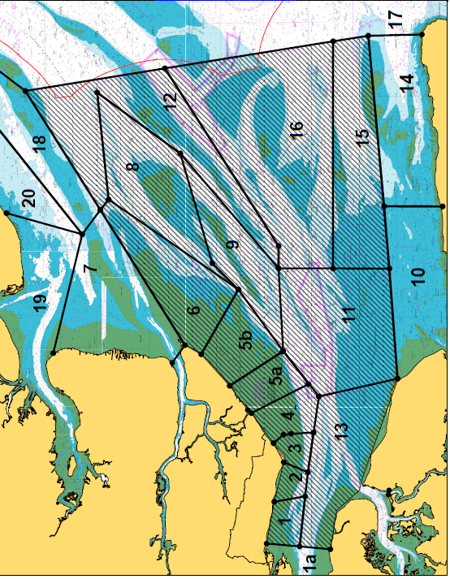
Southend Foreshore and Maplin Sands | North Thames | South Thames | Outer Thames and Channel Coast
☐ Area 1a  ☐ Area 1  ☐ Area 2  ☐ Area 3  ☐ Area 4  ☐ Area 5  ☐ Area 6 | ☐ Area 7  ☐ Area 8  ☐ Area 9  ☐ Area 10  ☐ Area 12  ☐ Area 18  ☐ Area 19  ☐ Area 20 | ☐ Area 11  ☐ Area 13  ☐ Area 14  ☐ Area 15  ☐ Area 16 | ☐ Area 17
Please provide rationale as to why you think the selected areas should be managed separately here. If you think that specific parts of any individual area should be managed in a certain way, please specify below:
Click or tap here to enter text.

S3B8. Do you think there would be any advantage of phasing in new regulations over a number of years or in stages? If so, specify how long and explain why.
Click or tap here to enter text.

S3B9. Any other comments or thoughts on regulatory options including types of legislation, spatial and temporal variations?
Click or tap here to enter text.

- Access to the cockle fisheries – licences and permits
This section seeks to gather views and data on the framework that could manage access to future cockle fisheries. As outlined in section A, there is an established survey and management process, that has been running over a number of years, and can produce a Total Allowable Catch (TAC) for a specified area. How access is managed, including how many licences/permits are issued, how TAC is divided between licences/permits, who gets a licence/permit, for how long and under what conditions, are all vital questions that will need to be resolved in developing future management not least as they will all have an impact upon the Marine Protected Areas which the cockle fisheries take place within.
How licences are issued under the current TECFO system

The Thames Estuary Cockle Fishery Order was set-up in 1994 and issued licences under the Regulating Order legislation. Licenses were issued to people that could provide written evidence (in the form of sales notes) of commercially fishing for cockles in the then proposed TECFO area. Twelve licences were initially issued and as the cockle stocks increased two more licences were issued under a temporary licence in 1997 following an assessment of the activities of all persons who demonstrated an interest. When stocks fell and the temporary licences were not issued, the temporary licence holders took Kent and Essex Sea Fisheries Committee (KESFC) (KEIFCA’s predecessor) to Judicial Review. KESFC lost the Judicial Review which in effect meant that temporary licences had the same legal standing as standard licences.

KESFC sought extensive legal advice as concerning the process and legal consequence of issuing new licences, as well as the legitimate expectation of the licence holders. The practical consequence of that legal advice meant that for the last 23 years KEIFCA has issued 14 licences to fish in the TECFO and the annual TAC has been divided evenly between the licence holders.

How permits are issued under the KEIFCA cockle fishery flexible permit byelaw (CFFPB).

The KEIFCA cockle fishery flexible permit byelaw (CFFPB) was confirmed in 2014 and brought together a number of different byelaws that had been used to manage the cockle fishery outside the TECFO area. To gain access to the fishery and become a permit holder, applicants need to provide identification and vessel details as well as pay a permit fee by the 31 March.

If the survey data indicates that the available stock is in excess of the criteria in the management plan, and the authority decides to open the fishery, then the available TAC is equally divided by the number of permit holders. Permits are issued on a yearly basis and if the fishery is not opened the licence fee is returned to the applicant.

S3C1. How do you think permissions to access the fisheries (permits/ licences) should be issued?
Click or tap here to enter text.

S3C2. Do you think there should be criteria to decide who should have a permit/licence to fish or do you think it should be open to all?
Choose an item.

S3C3. If you think there should be criteria, what criteria do you think there should be? (Tick all that apply)
☐ Those who have had a permission to fish for cockles in the TECFO
☐ Those who have had a permit to fish in the CFFPB
☐ Those who have commercially fished for any species in the Thames
☐ Those who have commercially fished for any shellfish in the Thames
☐ Those who have fished for cockles anywhere else
☐ Other

If ‘other’ please provide details:
Click or tap here to enter text.

S3C4. Do you think criteria should be weighted or have scores assigned to them? Please provide details
Click or tap here to enter text.

S3C5. Do you think a licence/ permit should have to be in a person’s name or could it be in a company name?
Choose an item.
Please provide the reasons for your answer here:
Click or tap here to enter text.

S3C6. How many licences/ permits do you think should be issued in the current TECFO area? Why?
Click or tap here to enter text.

S3C7. How long do you think a licence/permit should be issued for?
1 year  ☐ | 3 years  ☐ | 5 years  ☐ | 7 years  ☐ | 10 years  ☐ | 30 years  ☐ | Other  ☐
Please say why here:
Click or tap here to enter text.

S3C8. If licences/permits were to be issued through a bidding process, what would your thoughts and comments be?
Click or tap here to enter text.

S3C9. If the annual cost of licences/ permits included an amount to help support the wider fishing industry (a community fund for example), what would your thoughts and comments be?
Click or tap here to enter text.

S3C10. If new fishermen are going to enter the fishery, fishermen would also have to leave the fishery, otherwise the fishery just gets bigger and bigger. How do you think this should work?
For people to be able to enter the fishery
Click or tap here to enter text.
For people to leave the fishery.
Click or tap here to enter text.

S3C11. If new licences/permits are issued, who do you think they should go to? (in priority order)
Click or tap here to enter text.

S3C12. There are a number of businesses that have been fishing for cockles in the TECFO area for over 30 years and have business models that rely on that activity. How do you think this should influence how fishing opportunities are allocated?
Click or tap here to enter text.

S3C13. What could we do to make the fishery greener? Explain how for each category.
Boats | Click or tap here to enter text.
Transport | Click or tap here to enter text.
Logistics | Click or tap here to enter text.
Company Statement – CO2 footprint offset | Click or tap here to enter text.
Any other comments | Click or tap here to enter text.

S3C14. Any other comments or thoughts on access to fisheries?
Click or tap here to enter text.

- The economics of the cockle fisheries
Catching sector
S3D1. How much does it cost to run a cockle boat each year? | £ Click or tap here to enter text.
S3D2. What kind of turnover do you need to make your business viable? | £ Click or tap here to enter text.
S3D3. What kind of annual quantity of cockles do you need to make your business viable? | Click or tap here to enter text.
S3D4. How many people do you employ in your catching operations? | Click or tap here to enter text.
S3D5. How many additional on-shore jobs does your cockle fishing business support? | Click or tap here to enter text.
S3D6. What percentage of your turnover is related to fishing for cockles in the KEIFCA District? | Click or tap here to enter text.

Processing Sector
S3D7. What do you need out of the fishery?
Click or tap here to enter text.

S3D8. What is the maximum demand from the Thames cockle fisheries (in terms of tonnage) by the market?
Click or tap here to enter text.

S3D9. How many people do you employ in your processing operations? | Full time Click or tap here to enter text.
 | Part time Click or tap here to enter text.
 | Number of months per year part time workers are employed Click or tap here to enter text.

All sectors
S3D10. Describe the investment you have put into the KEIFCA District cockle fisheries over the last 10 years?
Click or tap here to enter text.

S3D11. Is there anything that could be done to make the KEIFCA District cockle fisheries more cost efficient?
Click or tap here to enter text.

S3D12. Is there anything that could be done to bring in or create more jobs based in KEIFCA district?
Click or tap here to enter text.

S3D13. What would be the impact on you and your business if the current management systems were to be extended for a further 5 years/ 10 years/ 30 years?
Click or tap here to enter text.

S3D14. What would be the impact on you and your business if there was a yearly permit issued for the current TECFO area using similar criteria to the current KEIFCA cockle permit fishery?
Click or tap here to enter text.

S3D15. Any other comments or thoughts on the economics of the fisheries?
Click or tap here to enter text.

- The proposed process for reviewing and developing future cockle management
The cockle fisheries are one of the most important but complex fisheries in the KEIFCA district. The fisheries take place within a complex mosaic of Marine Protected Areas (MPAs) and the cockle stocks provide food for a wide range of bird and fish species, whilst also providing other functions like filtering water and capturing CO2 in their shells. The cockle fishery provides income and jobs for a large number of fishermen and, with seaside towns like Leigh-on-Sea and Whitstable, provide tourist and cultural links between the cockle fishery and the wider society. Although it is complex, we do want to hear and gather views on how the cockle fisheries could be run in the future from a wide spectrum of stakeholders that are involved and impacted by the fishery.
Process outline

The proposed process to review and develop future cockle management, is split into a number of time defined steps that will build on each other (below), with the overall aim of confirming new legislation (in whatever form it might look like) to be in place for when the current TECFO legislation ends in September 2024.

The first step is to undertake a specific listening and evidence gathering exercise, the second step looks at the framework of any future fisheries management, the third step develops the technical detail and final wording of any proposed legislation, and the fourth step takes the proposal through the statutory consultation and confirmation process of the agreed new legislation. With each step we have identified provisional processes and meeting dates, with the aim of setting out a clear process that helps everyone understand when, where and what could be decided at each stage.

For more detail, including potential engagement events and dates please follow this link: https://www.kentandessex-ifca.gov.uk/news/review-of-management-of-cockle-fisheries-in-the-kent-and-essex-ifca-district

S3E1. Do you have any thoughts or comments with the proposed process for reviewing and developing new cockle fisheries management in the TECFO area and the wider KEIFCA district?
Click or tap here to enter text.

S3E2. Are there any changes you would make to the provisional review process outlined above?
Click or tap here to enter text.

S3E3. Does the process provide a mechanism to adequately address the key issues as you see them?
Click or tap here to enter text.

S3E4. How can we best represent your views during the review process?
Click or tap here to enter text.

S3E5. Any other comments or thoughts on the review and development process?
Click or tap here to enter text.

Thank you for taking the time to complete this questionnaire. Your responses are invaluable in helping us to review the current management of cockle fisheries within the KEIFCA District, and in helping us develop new management for the future.

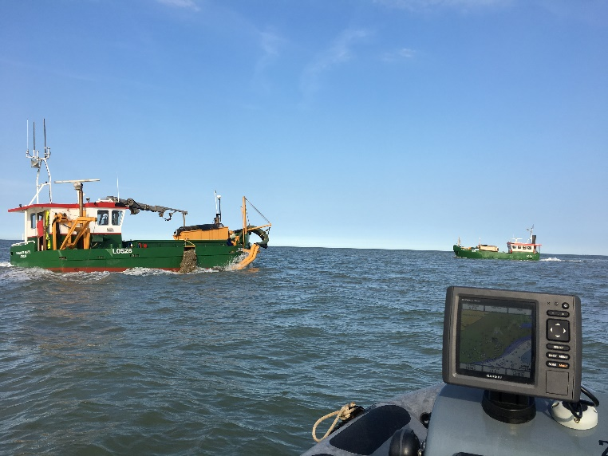 | 